

SITE INFO 

Site Created and Designed by-

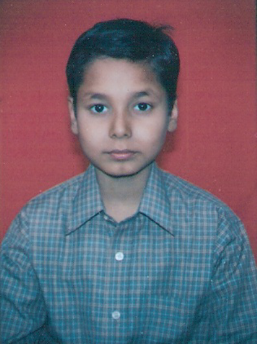 Ashu Prakash
Class- IX ‘A’, Adm. No. 1774
Session- 2009-10

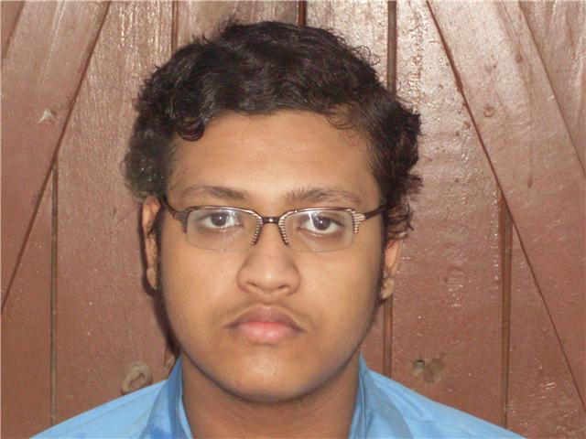 Shourajeet Chakroverty
Class- IX ‘A’, Adm. No. UKG-II
Session- 2009-10

Some photos taken by-

Ganendra Narayan
Aman Aditya

Courtesy-

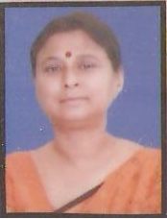 Mrs. Archana Sharan
VICE PRINCIPAL (Gyan Niketan, VVC)

Some help taken by-

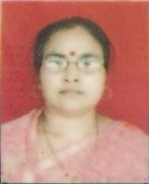 Dr. Sabita Prasad
COMPUTER TEACHER

Website created in Drive D:/
D:\gns\GYANNIKETAN.COM_homepage_new.htm

